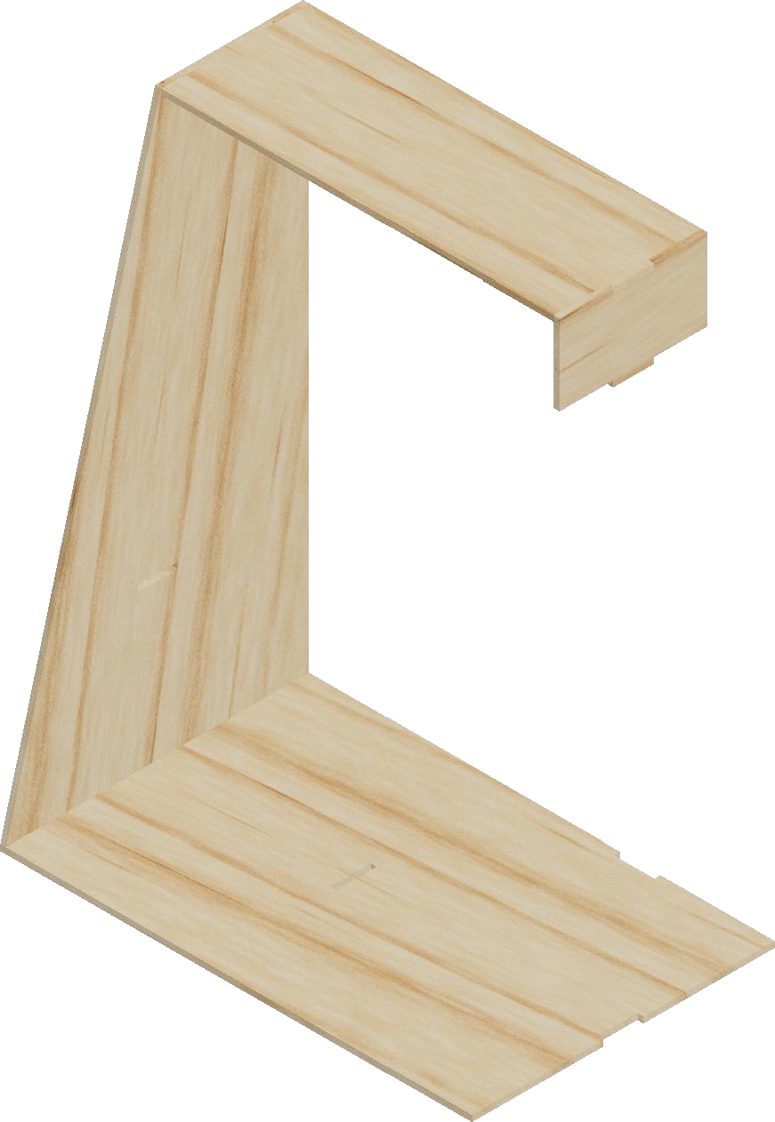
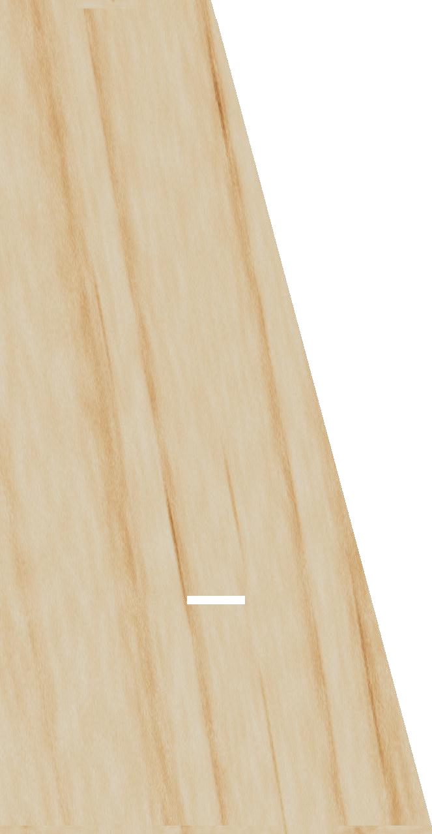
Vista home
BB
CC
DD
EE
Dept. Technical reference Created by Approved by
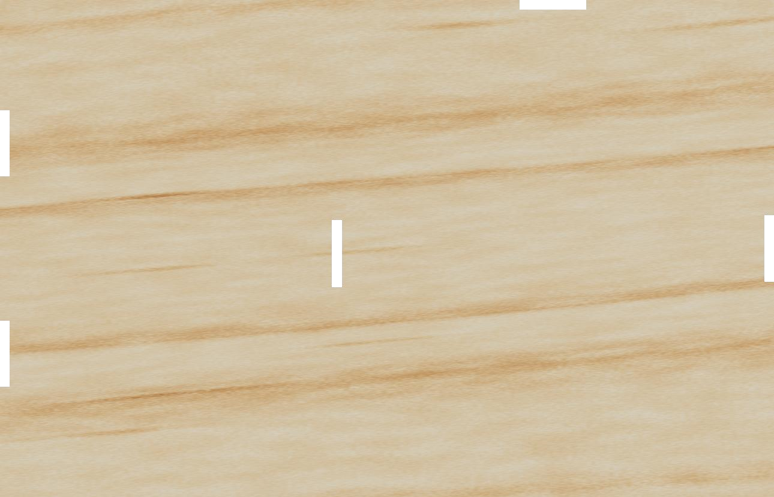
B
C
D
E
B
C
D
E
Dept.
Technical reference
Created by
Approved by
70
10
17
19.5
30
45
Parte inferior
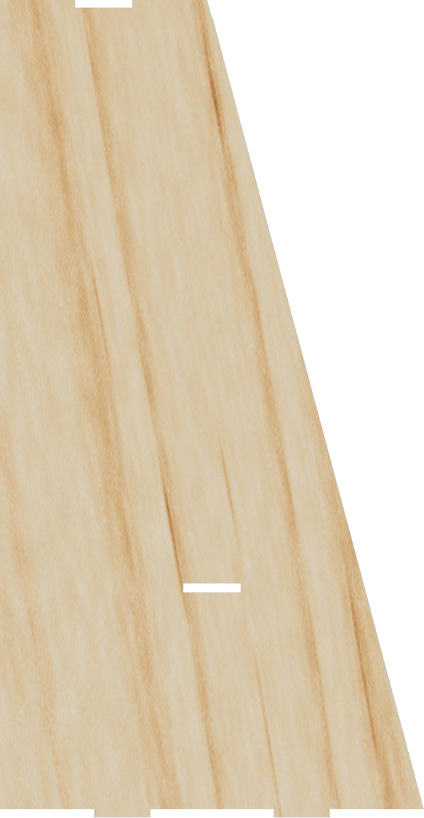
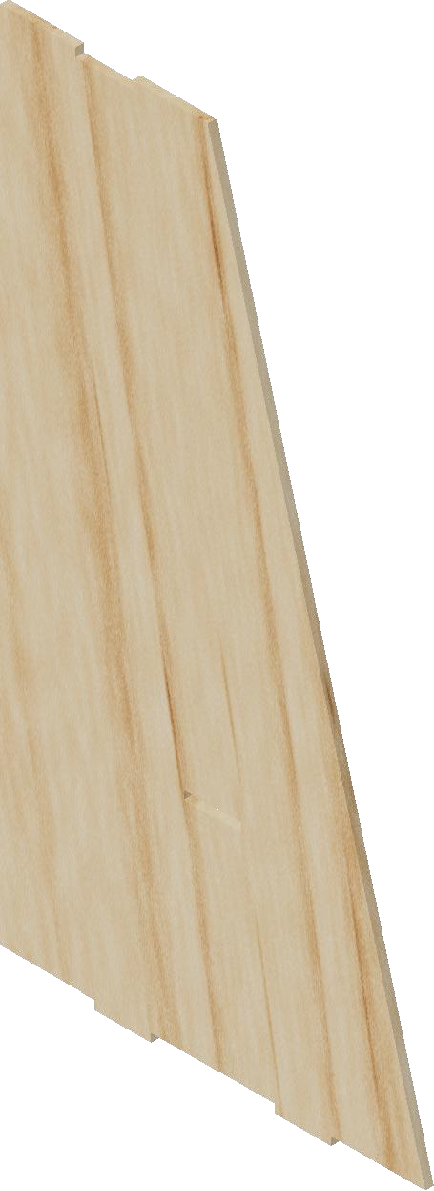
Parte lateral
8
86
45
10
23
89.02
22
BB
CC
DD
EE
Dept. Technical reference Created by Approved by

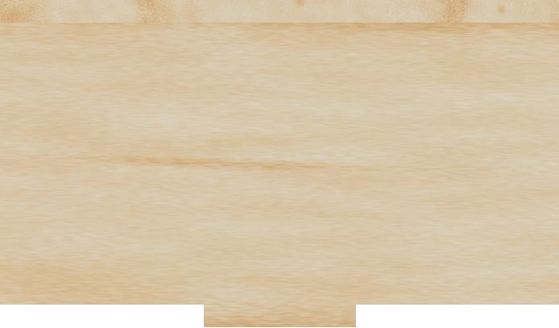
Parte superior
B
22
8
11.1
8
12.9
60
B
C C
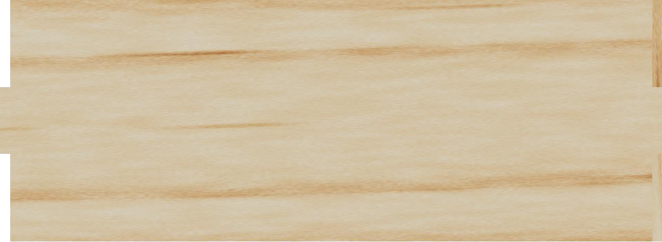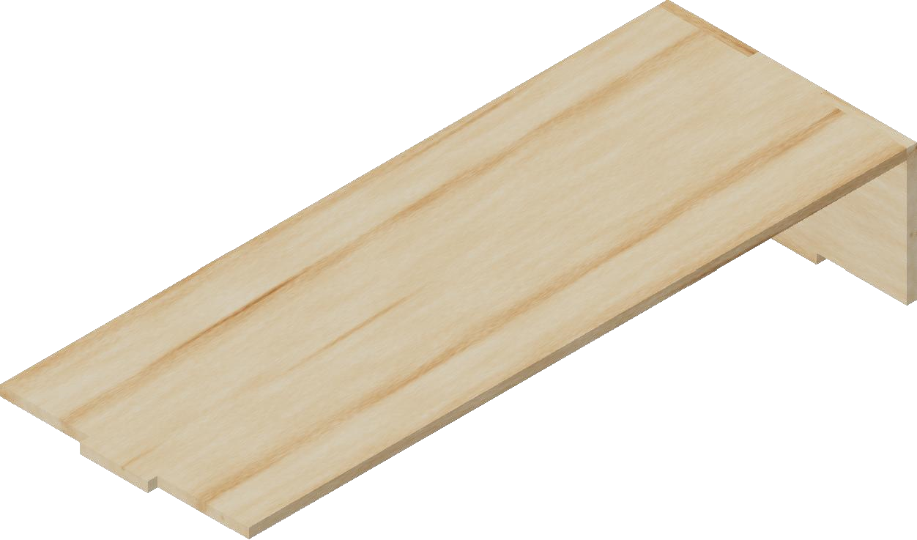
D
D
58.2
8
22
8
E E
Dept. Technical reference Created by Approved by

