1 2 3 4 5 6 7 8

- A

38.6

B
20.3

- C
31.39
.5

D
51.66

E

Puertas
E

Dept. Technical reference Created by Approved by

Fabricio Cuba
Document type

30/04/2021

Document status

Title
F PUEERTAS DE CAJONES
DWG No.

F

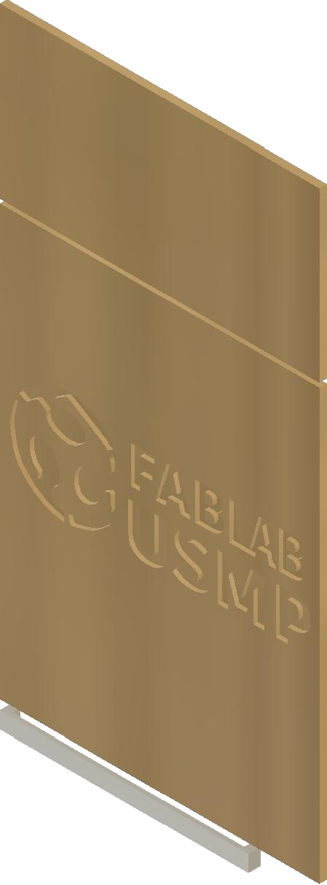

1 2 3 4

5 6 7
Rev.
Date of issue
Sheet

1/2

8

