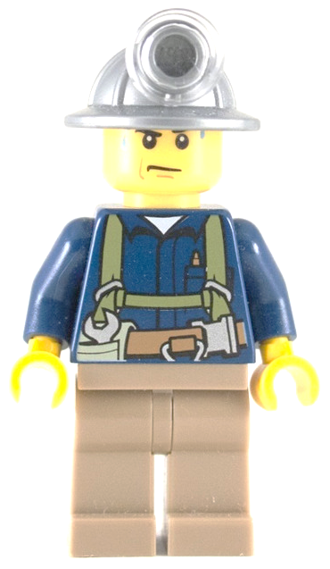
SELECT ENTER


RADIAL FRACTURE
HOPELESS CASE
WRENCHED KNEE
INNER CHILD
FUNNY BONE
MENTAL BLOCK
ON/OFF

